EXPERIMENT NO. 8
Aim: Implement Linear, Logistic and KNN Models for various datasets.
Roll No:- 60
★ PROGRAM 1 – LINEAR REGRESSION
Program:
import pandas as pd
import matplotlib.pyplot as plt
from sklearn.linear_model import LinearRegression
data = {'Temperature': [20,22,24,26,28,30],
'Consumption': [120,135,150,165,180,195]}
df = pd.DataFrame(data)
X = df[['Temperature']]
Y = df['Consumption']
model = LinearRegression()
model.fit(X, Y)
prediction = model.predict([[32]])
print("Predicted consumption at 32°C:", prediction[0], "kWh")
plt.scatter(X, Y, label="Actual Data")
plt.plot(X, model.predict(X), label="Regression Line")
plt.xlabel("Temperature (°C)")
plt.ylabel("Electricity Consumption (kWh)")
plt.title("Temperature vs Electricity Consumption")
plt.legend()
plt.show()
Output:
Predicted consumption at 32°C: 210.0 kWh
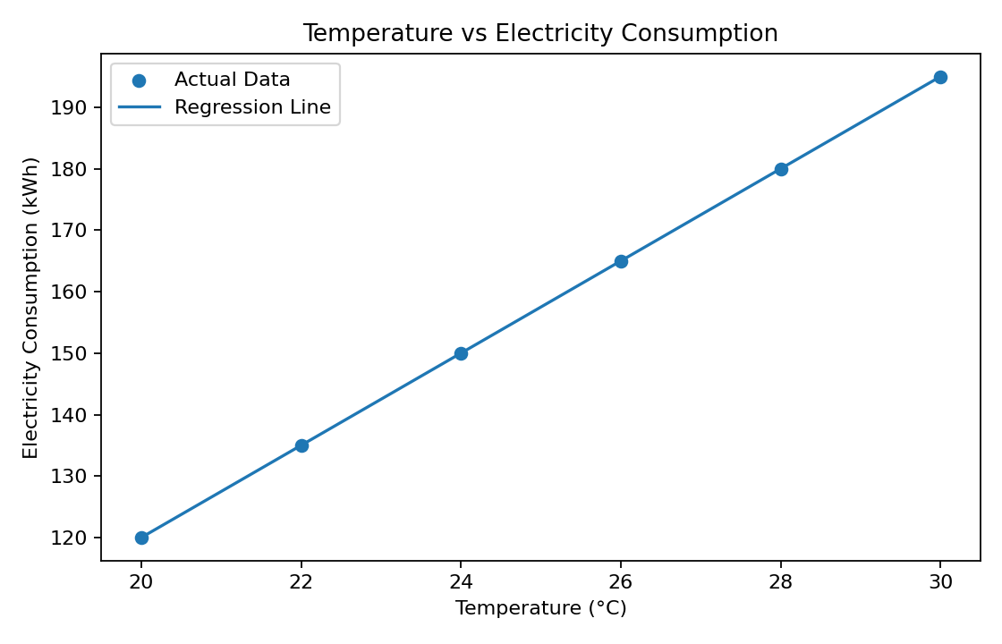

★PROGRAM 2 – LOGISTIC REGRESSION
Program:
import pandas as pd
from sklearn.linear_model import LogisticRegression
from sklearn.model_selection import train_test_split
from sklearn.metrics import accuracy_score
data = {'Study_Hours': [1,2,2,3,4,5,6,7,8,9],
'Result': ['Fail','Fail','Fail','Fail','Fail',
'Pass','Pass','Pass','Pass','Pass']}
df = pd.DataFrame(data)
X = df[['Study_Hours']]
y = df['Result']
X_train, X_test, y_train, y_test = train_test_split(
X, y, test_size=0.3, random_state=42)
model = LogisticRegression()
model.fit(X_train, y_train)
y_pred = model.predict(X_test)
print("Actual Result:", list(y_test))
print("Predicted Result:", list(y_pred))
print("Accuracy:", accuracy_score(y_test, y_pred))
Output:
Actual Result: ['Pass', 'Fail', 'Pass']
Predicted Result: ['Pass', 'Fail', 'Fail']
Accuracy: 0.67

★PROGRAM 3 – KNN MODEL (STUDENT )
Program:
from sklearn.neighbors import KNeighborsClassifier
X = [[1], [2], [3], [5], [6], [7]]
y = ['Fail', 'Fail', 'Fail', 'Pass', 'Pass', 'Pass']
model = KNeighborsClassifier(n_neighbors=3)
model.fit(X, y)
prediction = model.predict([[4]])
print("Predicted Result:", prediction[0])
Output:
Predicted Result: Fail

PROGRAM 4 – KNN MODEL (MOTOR CONDITION)
Program:
from sklearn.neighbors import KNeighborsClassifier
X = [[2], [3], [4], [7], [8], [9]]
y = ['Normal', 'Normal', 'Normal', 'Faulty', 'Faulty', 'Faulty']
model = KNeighborsClassifier(n_neighbors=3)
model.fit(X, y)
result = model.predict([[7.5]])
print("Motor Condition:", result[0])
Output:
Motor Condition: Faulty

